San Diego Trial Firm Increased Organic Traffic by 289% Year-Over-Year

SEO

Results that speak for themselves

Key Stats & Results


289% Year-over-year organic traffic growth

$112K Monthly traffic value (up from $29K)

Behind the transformation

289% Organic Traffic Growth for a San Diego Trial Law Firm
A leading San Diego trial firm partnered with Rankings.io to revive its organic search performance after years of stagnant growth. Through a comprehensive Three Pillar SEO strategy—combining content marketing, on-site optimization, and off-site authority building—the firm achieved 289% year-over-year organic traffic growth, secured 175 top-3 keyword rankings, and increased its estimated monthly traffic value from $29K to more than $112K. In less than a year, the firm went from being buried in search results to dominating highly competitive trial lawyer keywords across the San Diego market.

FROM CHALLANGES TO SUCCESS


The Challenge
When this San Diego trial firm partnered with Rankings.io, the firm's founder came in with clear-eyed skepticism. Previous SEO providers had made the usual promises and failed to deliver. After nearly five years of flat organic performance, the firm needed results it could actually measure.
Despite being one of the pre-eminent trial firms in the San Diego area, the firm's website had seen virtually no meaningful organic traffic growth for close to half a decade. Previous SEO firms had produced content — but they didn’t structure, optimize, or distribute it in a way that allowed prospective clients to find it.
The stakes were clear: To grow its caseload and revenue, the firm needed to stop being buried in search results and start dominating them. That meant outranking competitors for high-value practice area keywords and expanding visibility into new geographic markets across the region.
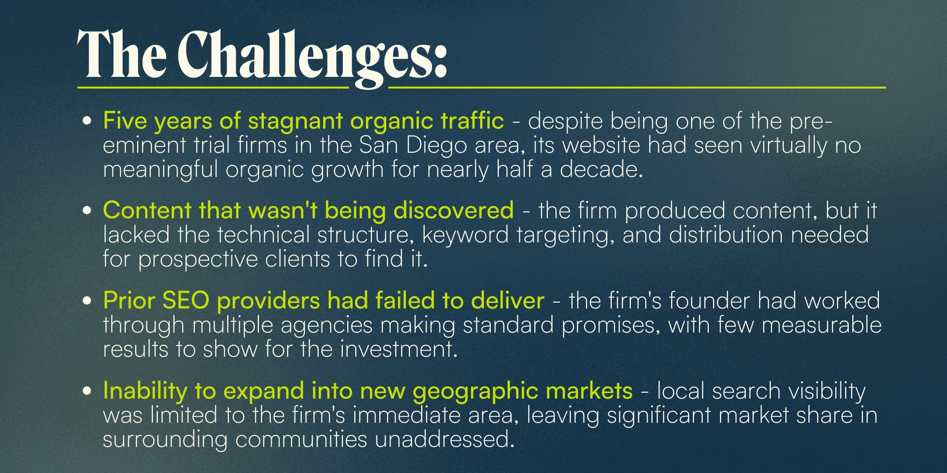



How We Did It: The Strategy
Rankings.io deployed a full Three Pillar SEO approach: content marketing, on-site optimization, and off-site authority building, designed to attack all the levers of organic growth simultaneously rather than in isolation.

Three Pillar SEO Strategy for a San Diego Trial Firm
Where most agencies focus narrowly on one channel, Rankings.io's integrated approach ensured that every element of the strategy reinforced the others, building compounding momentum across content, technical performance, and domain authority.

1. Content Marketing
Rankings.io added content modules, expanded the firm's content offerings, improved overall content quality, and added FAQ schema markup to improve organic search visibility and eligibility for rich results.
High-volume support articles allowed the firm to dominate its core areas of expertise and expand into new geographic markets across the San Diego region. We built custom landing pages around high-intent keywords, including practice area terms like “brain injury lawyers,” to capture demand at the moment of search.

2. On-Site SEO
Rankings.io improved the site's internal linking architecture and restructured the navigation menu to optimize the experience across both desktop and mobile. Technical improvements addressed overall page speed, and we enhanced the site's custom-coded sidebars and visual design to improve both usability and search performance.

3. Off-Site SEO — Local SEO & Link Building
Rankings.io built hundreds of local citations and added a substantial volume of images to the firm's Google Business Profile, establishing a strong foothold in local search results across the San Diego area.
On the link-building side, Rankings.io went well beyond standard guest posting and directory submissions. The team researched, wrote, edited, published, and promoted original content, then performed outreach to prominent media outlets.
A standout example: An industry-first COVID-19 workplace protection survey of 5,650 Americans, visualized as an interactive chart, earned coverage from authoritative sources, including The Denver Post, generating high-quality backlinks that materially strengthened the firm's domain authority.



Before & After
In just six months, the firm went from being buried in search results to dominating its market. The results, across traffic, rankings, and traffic value, reflect what a fully integrated SEO strategy can achieve when a marketing firm executes every pillar at the highest level.
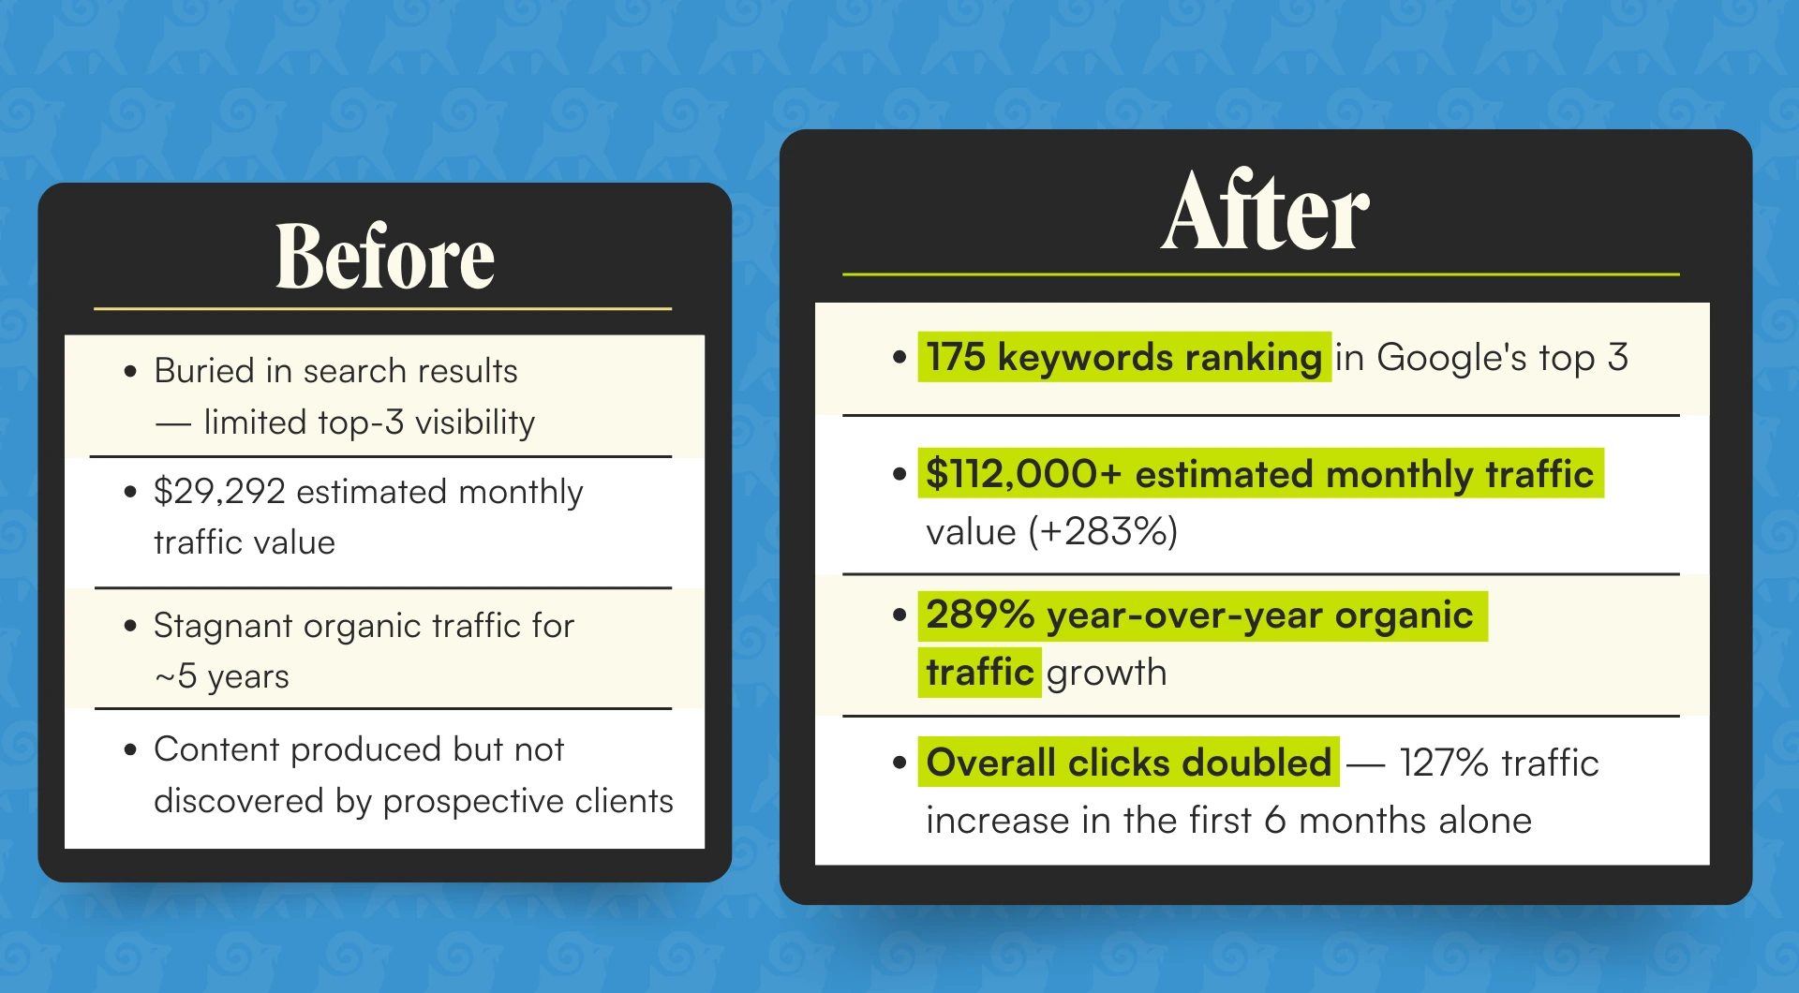
Rankings.io's assessment of the results: All tracked keywords showed "insane, massive growth." The firm now holds #1 organic rankings for “Car Accident Lawyer,” “Brain Injury Lawyer,” and “Brain Injury Attorney” in the San Diego area, the most competitive terms in its market.

Key Wins
- 289% year-over-year organic traffic growth — from near-stagnant to market-dominating in under a year
- 127% traffic increase in the first 6 months, with overall clicks doubling in the same window
- 175 keywords ranking in Google's top 3 — including #1 organic rankings for “Car Accident Lawyer,” “Brain Injury Lawyer,” and “Brain Injury Attorney” in San Diego
- Traffic value grew from $29,292 to $112,000+ per month
- Industry-first linkable asset — a COVID-19 workplace protection survey of 5,650 Americans, visualized as an interactive chart, earned coverage from authoritative outlets, including The Denver Post
- Successful geographic expansion — high-volume support articles extended the firm's visibility into new markets across the San Diego region

Ready to Grow Your Firm?
This case study shows what a fully integrated Three Pillar approach—content marketing, on-site SEO, and off-site authority building—can achieve for trial firms competing in dense, high-value legal markets.
At Rankings.io, we specialize exclusively in SEO for lawyers. We go beyond guest posts and directory submissions to build the kind of linkable assets and strategic content that generate compounding organic growth.
Keywords are vanity. Traffic is where it's at. Let's build yours.

